Anything you need to do to install and run the program. Environment variables
build configs, auth0 configs, dependencies

RUNNING THE APPLICATION

Pre requisites
Inorder to run the application your system must meet these prerequisites
System Reqiurements:
- CPU: 64-bit x86_64 processor. Recommended to have at least 2 CPU Cores
- RAM: 8 Gigabytes of Ram is Recommended at a minimum
- Disk: 5 GB of Free Space
- OS: A Recent version of One of the Following Linux Distributions (Ubuntu, Linux mInt, Debian, Arch Linux, Fedora)
As well as this your system must have the following dependencies installed, These dependencies are also referenced in the provided technical report in greater detail:
- Node js, At Least Node Js version 20 so its Vite Compatible
  - Can be installed from the Node Js Official Website
  - https://nodejs.org/en/download
  - Ensure to select Linux When installing
  - Verify the version of Node JS using node –version. The version should be at least v20.0.0

- npm (Node Package Manager):
  - Should be at least version 10.0.0
  - should be isntalled when you install nodejs

- Python3
  - Should be at least version 3.8
  - can be installed with the following command “sudo apt install python3 -y”

- MitmProxy
  - The main proxy application used for the blocking mechanism
  - Can be installed with the rest of the dependencies using the command at the bottom of the list

To Being running the program, you must clone the git repository and install the npm dependencies. This can be done with the following commands.

- git clone (ssh url of the repository)
- cd (Repository Folder)
- npm install

Our Applicaiton relies on VITE’s environment variables for auth0 credentials. These are used for our auth0 implementation. For authentication to work there must a file called (.env.production) in the root directory of the project. Here is an example of the layout:
IMPORTANT NOTE: This file has been provided as a part of submission, in AR-573-code.zip

line 1 - VITE_AUTH0_DOMAIN=dev-xxxxxxcomxxxxxxx.au.auth0.com
line 2 - VITE_AUTH0_CLIENT_ID=xxxxxxxxxxxxxxxxxxxxxxxxxxxxxxxx

Replace the placeholder text with the client ID and Domain of your auth0 application

Run Commands
To run the Application the main npm scripts used are the following:

- npm run start:prod
  - Starts the application in vite production mode, the default way to run the program
  - uses a vite dev server and launches electron
- npm run package
  - Creates an AppImage Packaged application.
- npm run package:all
  - creates a the following files
  - AppImage File – universal package format
  - .deb file – used for Ubuntu/ Debian based linux distributions
  - .rpm file – used for fedora based linux distributions

CONFIGURATION OF THE BLOCKING MECHANISIM

Overview:
The blocking mechanism establishes the core functional component of the ‘Focus Bear Linux App’. The purpose of the mechanism is to prevent users from accessing distracting websites by blocking specific domains (e.g., facebook.com), subdomains (e.g., news.yahoo.com, or nine.com.au/entertainment), and based on keywords (e.g., games, news, entertainment).
The implementation continuously developed over multiple sprints, resulting in a proxy-based solution using mitmproxy that performs both (sub)domain blocking and keyword blocking, while also being able to redirect to a custom Focus Bear branded block page.
Background of the Blocking Mechanism Development:
Initial Research:
Development began by researching existing Linux blocking and parental control apps. Two well-rounded solutions were identified:
- focus (ChetanXpro): used /etc/hosts modification method for domain blocking.
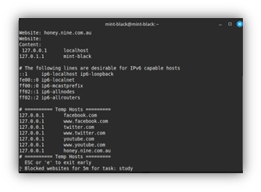
- nosurfin (bunsenmurder): used a proxy-based approach (mitmproxy) for keyword blocking with capability, if extended, to do page redirection and (sub)domain blocking.
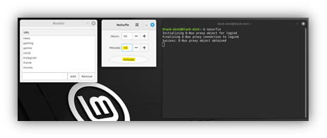
Initially, fulfilling the domain/subdomain blocking deliverable was prioritised and was given its own Sprint. Hosts file method was chosen and developed due its simplicity and efficiency.
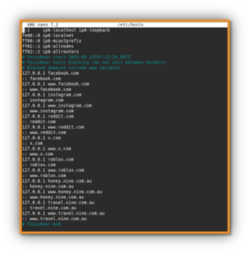
Later the hosts file method was dissolved as testing confirmed that the proxy-based solution provided better control and allowed redirecting users to a custom block page. Therefore, mitmproxy was decided as the final blocking approach.
Key files and directories related to the blocking mechanism:
focus-bear-for-linux/
├── src/
│ ├── electron/
│ │ ├── main.js
│ │ ├── focusbear_hosts_blocker.cjs
│ ├── python/
│ │ ├── mitmproxy_blocker.py
│ │ ├── set_system_proxy.py
│ ├── ui/
│ │ ├── focusbear_blocked.html
Key Components of the Blocking Mechanism:
- mitmproxy blocking script (/src/python/mitmproxy_blocker.py): A custom Python addon script for mitmproxy that intercepts all HTTP and HTTPS traffic. This file includes the blocking logic for (sub)domain & keyword blocking as well as redirection to custom block page.
- Blocklists: Two plain text files “focusbear-blocklist.txt” and “focusbear-keywords.txt” that store user-defined (sub)domains and keywords respectively. They are generated when the user adds (sub)domains or keywords to be blocked to their blocklist and stores in the /tmp directory.
- Proxy configuration script (/src/python/set_system_proxy.py): Script that configures the user’s system proxy settings to route through mitmproxy when starting/ending the focus session. Primarily relies on ‘gsettings’ and ‘kwriteconfig5’ methods to set system proxy – different desktop environments rely on specific methods.
- Custom Block Page (src/ui/focusbear_blocked.html): A locally hosted HTML page that users will see when a website is blocked, styled to match the Focus Bear brand. Further to this, it shows the block reason (e.g., domain or keyword) and what it blocked.
  - If reason = domain, then it will show the domain that was blocked (e.g., Blocked due to: domain, Matched value: facebook.com).
  - For keywords, it will show blocked due to: “keyword in url” or “keyword in page title”, then show the keyword that triggered the block (e.g., Blocked due to: keyword in page title, Matched value: games).
- [NOT IN USE ANYMORE] Hosts file blocking script (src/electron/focusbear_hosts_blocker.cjs): It is now obsolete/deprecated due to its replacement by proxy-based (mitmproxy) solution, which offers superior functionality including (sub)domain blocking, keyword blocking, and custom page redirection. This note is included in the key components section for future developer reference.
- main.js (electron main process): This file connects the GUI buttons to the actual blocking system.
- What it does: When you click “Start Focus Session” in the app, this file:
  - Receives the command from the GUI
  - Sets the system proxy to use the blocker
  - Starts the mitmproxy blocking engine
  - Tracks whether blocking is active.
- Key Features:
  - Handles the “Start/End Focus Session” buttons clicks
  - Manages the mitmproxy process (starts and stops it)
  - Contains old hosts-file blocking code (commented out)
  - Automatically stops blocking when app closes
  - Helps with certificate checking for setup
How the Blocking Works:
- Session Start: When a user clicks “Start Focus Session” in the GUI, the backend performs the following:
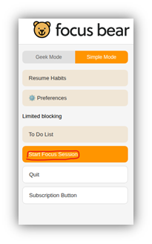
  - The proxy configuration script (set_system_proxy.py) is run, setting the user’s system proxy to mitmproxy (127.0.0.1:8080). This script applies multiple methods to ensure majority desktop environment compatibility (e.g., gsettings for GNOME/Cinnamon, kwriteconfig5 for KDE Plasma).
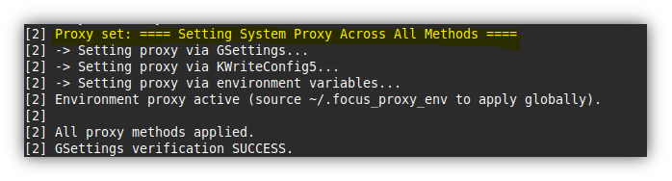
  - The mitmproxy script (mitmproxy_blocker.py) is started on 127.0.0.1:8080 using the mitmdump command.
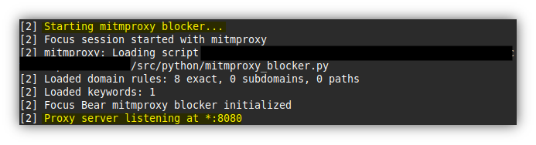
- Traffic Interception: All web traffic from the user’s browser is now routed through mitmproxy. Note: by default, the browser’s proxy settings should be set to “use system settings” allowing to use mitmproxy which is set from the system settings.
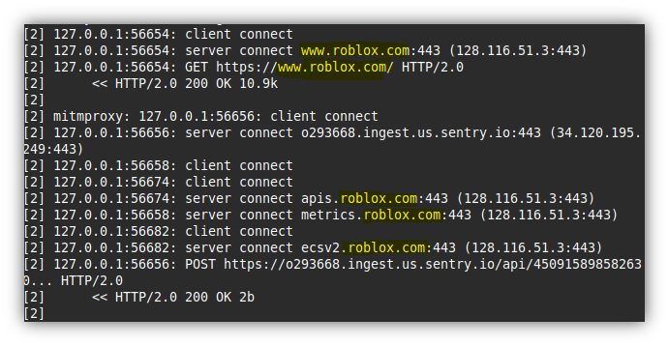
- Request Inspection: For every HTTP/S request, the mitmproxy_blocker.py script checks the request against the blocklists:
  - Domain/Subdomain Blocking: The request’s hostname is compared against the ‘focusbear-blocklist.txt’. If a match is found (e.g., facebook.com), the request is blocked.
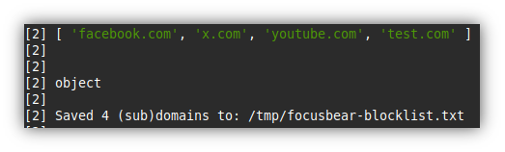
  - Keyword-Based Blocking: The request’s full URL and the HTML page title (once the response is received) are scanned for any words in the ‘focusbear-keywords.txt’. If a keyword is found the request is blocked.
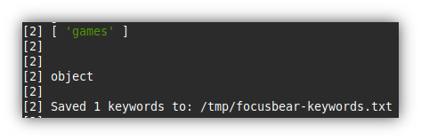
- Blocking Action: When a block condition is met, mitmproxy intercepts the request and responds with an HTTP 302 redirect to a local custom block page (focusbear_blocked.html), informing the user that the site has been blocked by focusbear.
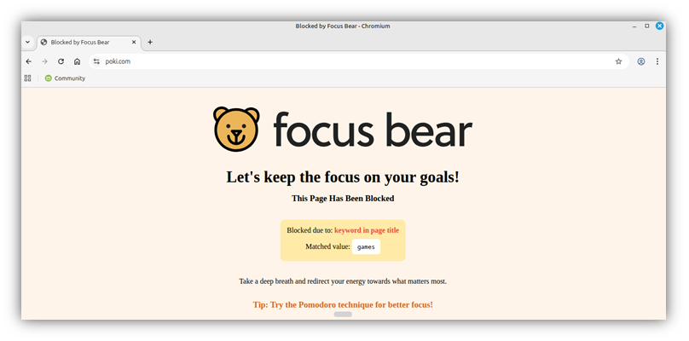
- Session End: When the user clicks “End Focus Session”, the system proxy settings are restored to their original state, and the mitmproxy process is terminated, allowing normal browsing to continue.
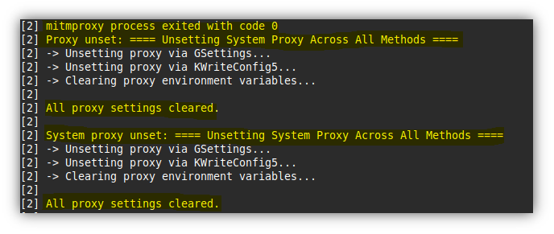
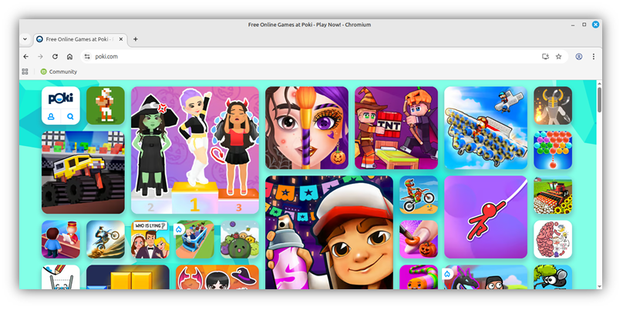
Screenshot illustrating normal browsing after ending focus session. poki.com is no longer blocked.

Next Steps & Recommendations:
The blocking mechanism delivered in this MVP meets the core requirements (domain/subdomain and keyword-based blocking) using mitmproxy and system proxy configuration. The following are recommended next steps for future developers to pick up features that were unable to be developed during this project period. They are intended to make the blocking mechanism more robust, user-friendly, and production-ready for a broad set of Linux distributions and desktop environments.
- Implement a Certificate Wizard
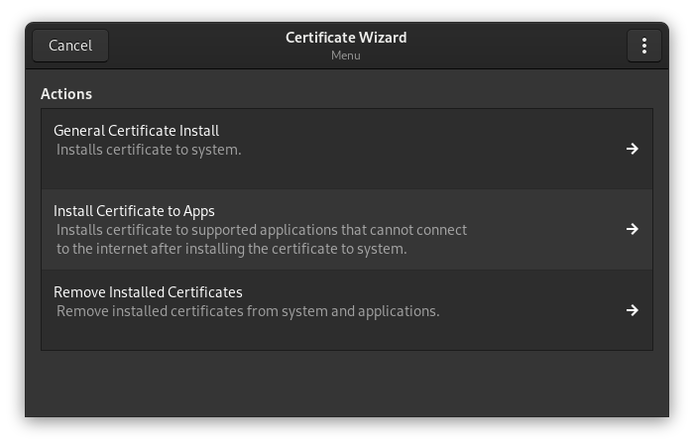
Image of Certificate Wizard from nosurfin.
Current Limitation:
Users must manually install and configure the mitmproxy Certificate Authority (CA) certificate on their system and in individual browsers (like Firefox). This process is technical, error-prone, and creates a significate barrier to entry, leading to a poor user experience and potential support issues.
Recommended Solution:
Develop an integrated Certificate Wizard using nosurfin by bunsen murder as both inspiration and technical reference. This open-source project, which already inspired our current blocking mechanism, provides a robust implementation that can be analysed and adapted.
Key Reference Files includes but not limited to:
- nosurfin/nosurfin/wizard.py - main wizard implementation and UI logic.
- nosurfin/nosurfin/nosurfin.d/sh_scripts/cert_util_pem - PEM certificate utilities
- nosurfin/nosurfin/nosurfin.d/sh_scripts/cert_util_sys - System certificate installation scripts
Implementation Approach:
Study these components to understand how nosurfin handles:
- Certificate detection
- System-wide installation
- Browser-specific configuration
- and Clean removal
The code provides proven patterns for managing certificates across different storage systems (NSS databases, PEM bundles) and handling the privilege escalation required for system-level changes.
Benefits:
- Eliminates complex manual setup steps that potentially currently challenge users
- Reduces installation errors and support requests
- Leverages existing, tested open-source solutions rather than building from scratch

- Transparent Proxy Implementation
Current Limitation:
The system proxy method relies on desktop environment settings, which may not work on all Linux distributions / desktop environments or with all applications that ignore proxy configurations.
Recommended Solution:
Implement transparent proxying using the proven approach from nosurfin by bunsenmurder. This method operates at the network level rather than the application level, ensuring universal compatibility.
Key Reference Files includes but not limited to:
- nosurfin/nosurfin/nosurfin.d/sh_scripts/network_setup.sh - iptables rules configuration
- nosurfin/nosurfin/nosurfin.d/sh_scripts/network_reset.sh - Clean restoration of network settings
- nosurfin/nosurfin/nosurfin.d/sh_scripts/run_as_root - Privilege escalation patterns
Implementation Approach:
Analyse how nosurfin uses iptables to redirect traffic transparently to the proxy and, crucially, how it ensures proper cleanup when sessions end. The run_as_root script provides secure patterns for handling the necessary sudo permissions without compromising system security.
How It Works:
- Configure iptables to redirect outgoing HTTP/HTTPS traffic directly to mitmproxy
- Run mitmproxy in --mode transparent to handle the redirected traffic
- Implement robust cleanup procedures to restore original network configuration
Benefits:
- Works reliably across all Linux distributions and desktop environments
- Cannot be bypassed by applications that ignore system proxy settings
- Provides consistent blocking regardless of user's desktop environment or browser choice
- Eliminates dependency on desktop-specific proxy configuration APIs

